­­­



Web Design Fundamentals

Project - Scenic Views

­­

Web Design Fundamentals - Website Project Assignment

Declaration

I the undersigned declare that the project material, which I now submit, is my own work. This material or project has not previously been submitted for any other assignment. Any assistance received by way of borrowing from previous work, or the work of others has been cited and acknowledged within the work. I make this declaration in the knowledge that a breach of the rules pertaining to project submission may carry serious consequences. We are aware that the project will not be accepted unless this form has been handed in along with the project.

Website Topic Scenic Views

Student name: Tania Winters

Student number: S00213820

Date: 21-04-2021

The Four Paged Web Design “Scenic Views”

GitHub URL (<https://taniawinters.github.io/ScenicViews/>)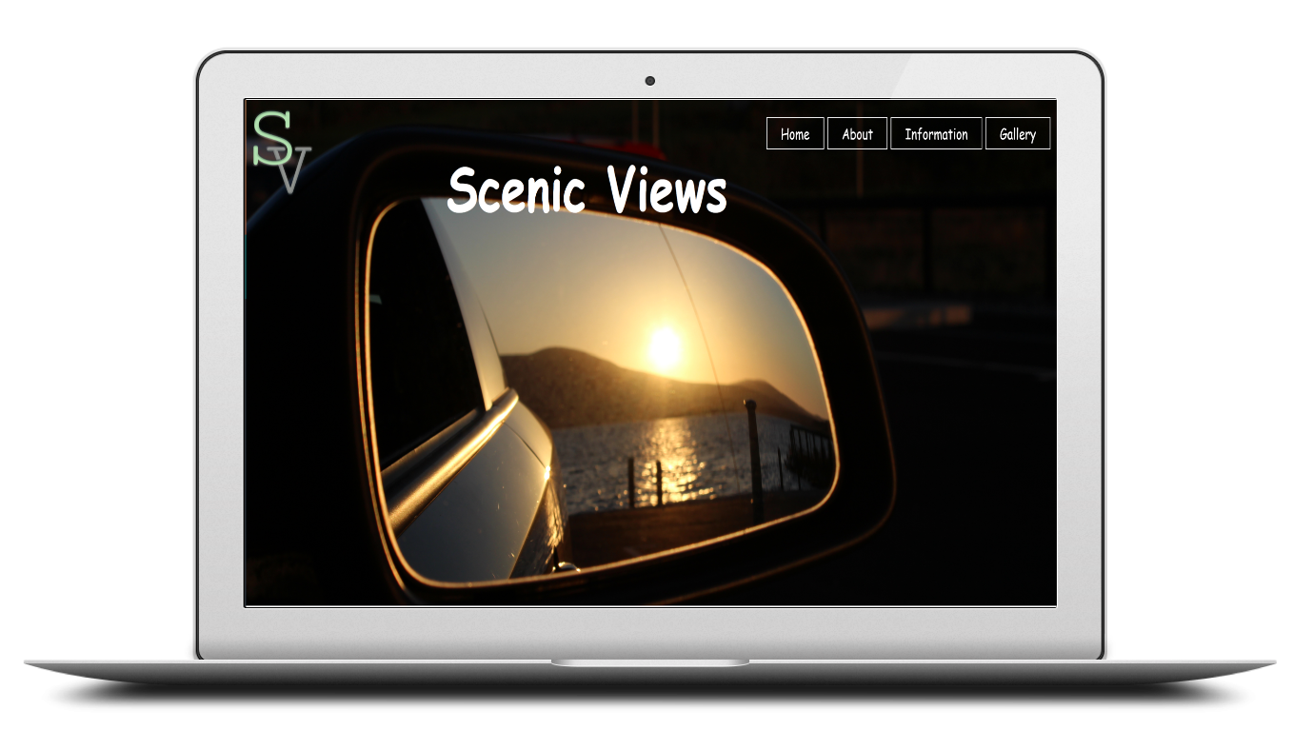

This website contains:

1. Index page
2. About page
3. Information page
4. Gallery page

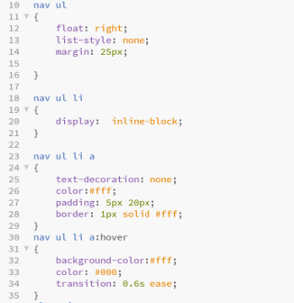 Consistency throughout the website:

1. Navigation – Nav CSS >
2. Footer
3. Scenic Views Logo
4. Copyright 2021
5. 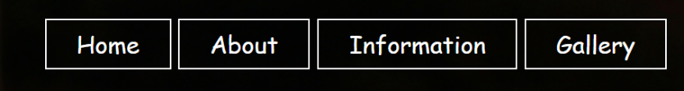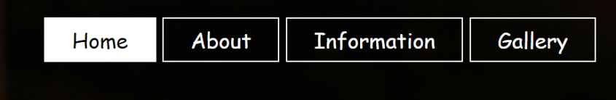CSS validation in footer image



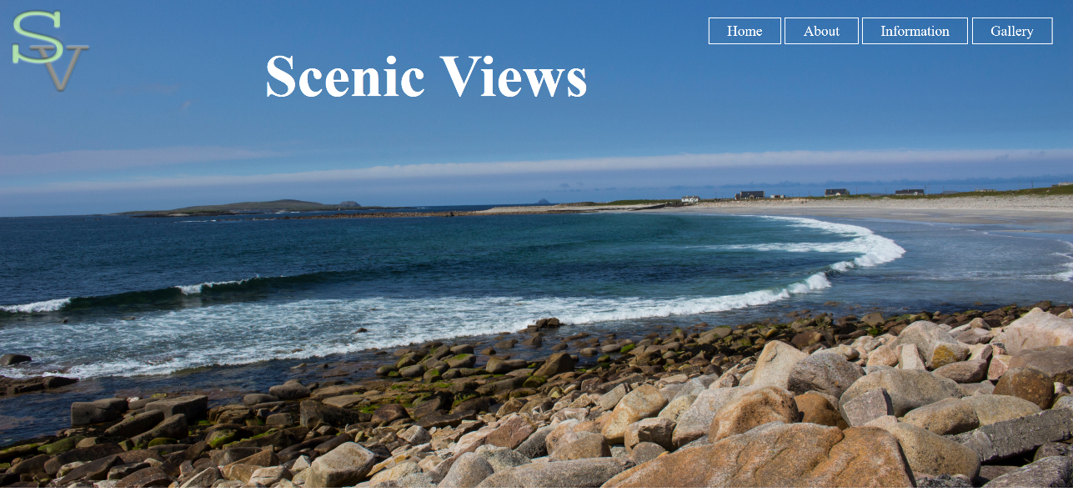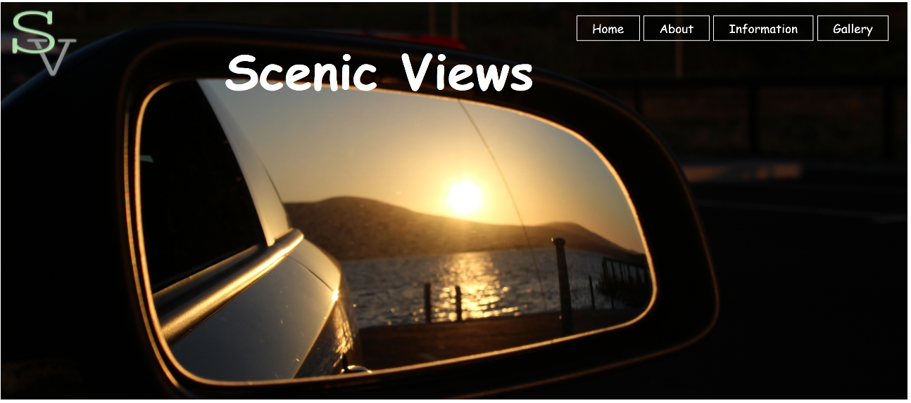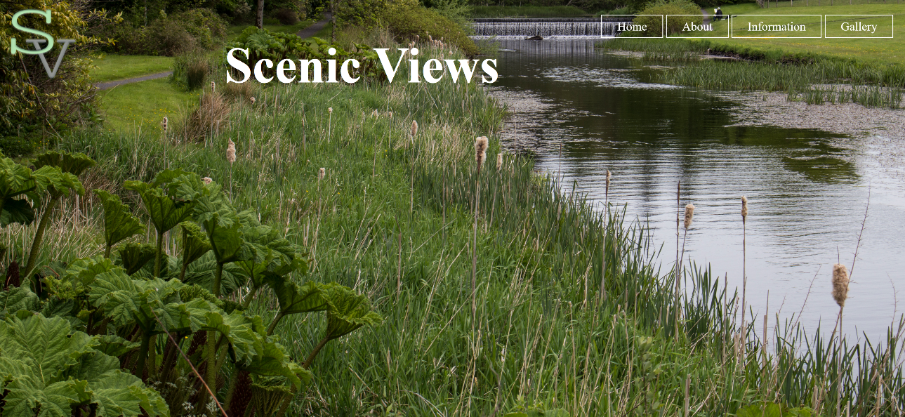Navigation is set for all pages on the website, which is in the <header> tag with <img> tag for Logo and Background image in CSS, the same navigation is displayed in the <footer> tag. The navigation has a hover effect of a background colour white once you hover over each <ul> tag that contains <li> with <a> tag that contains the link to each page.

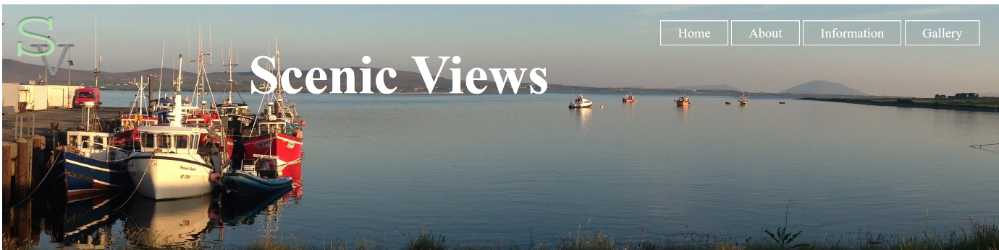

Index footer



Validation

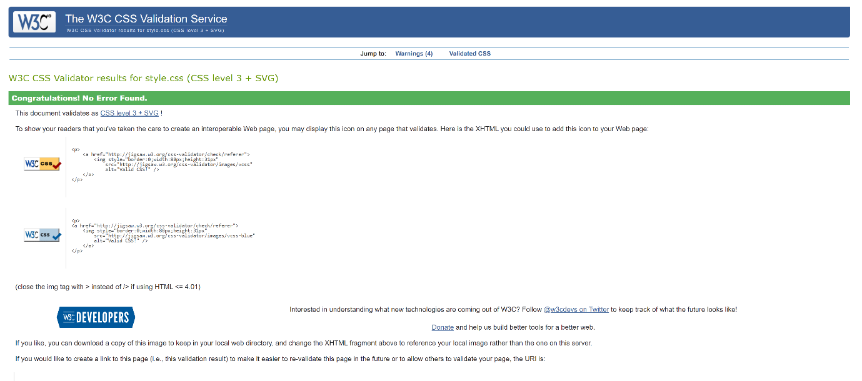

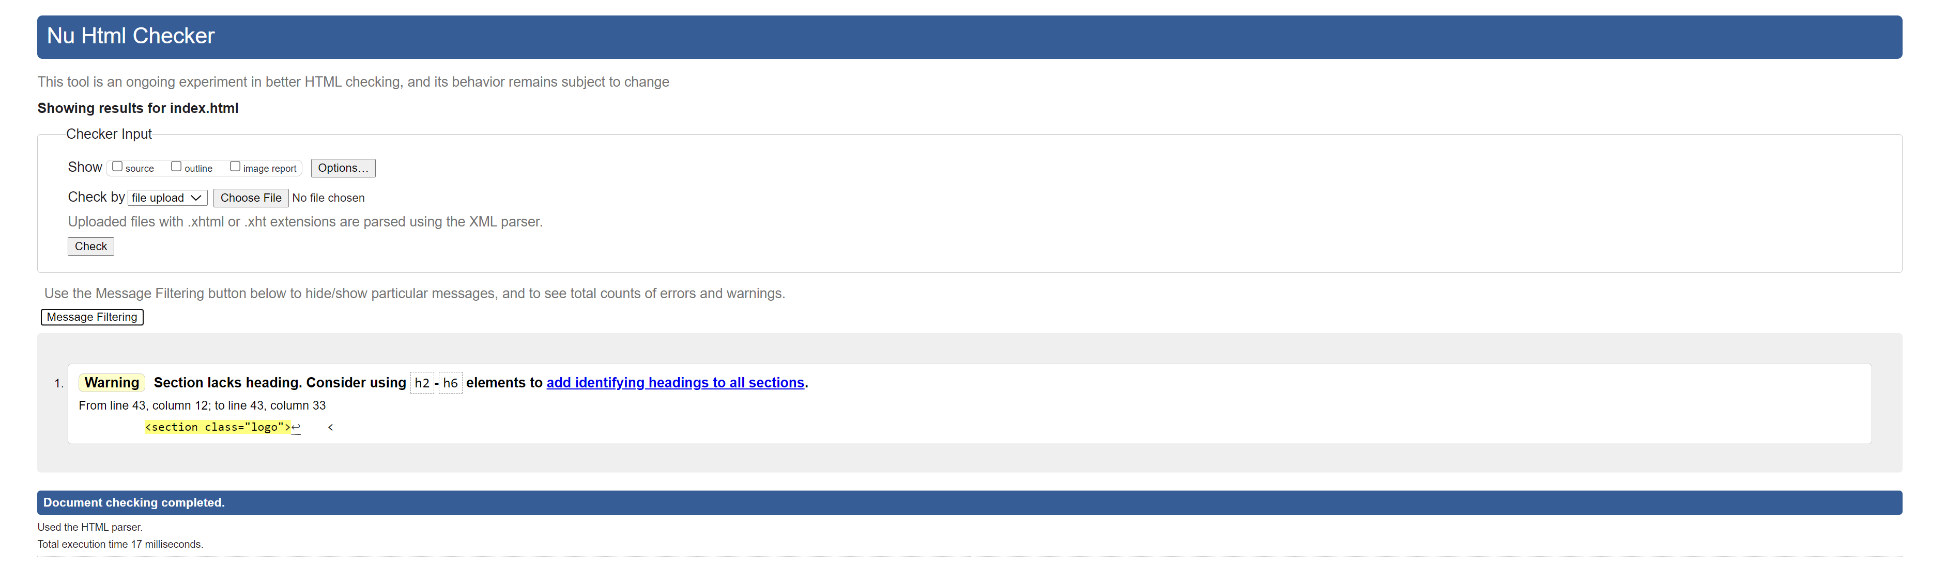

About footer



Validation

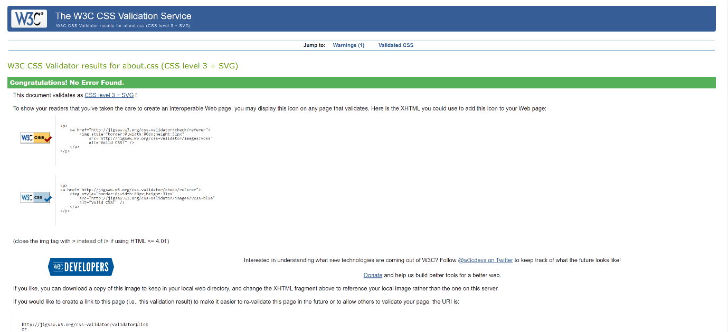

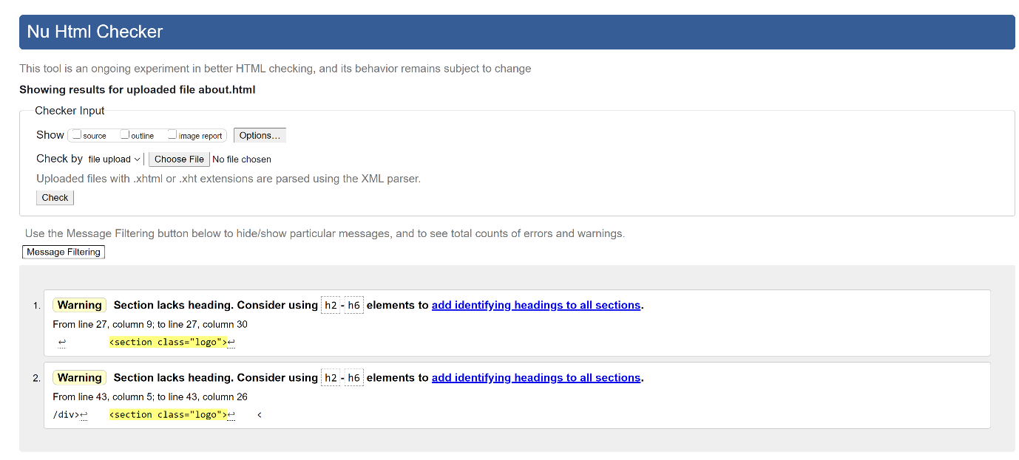

Information footer



Validation

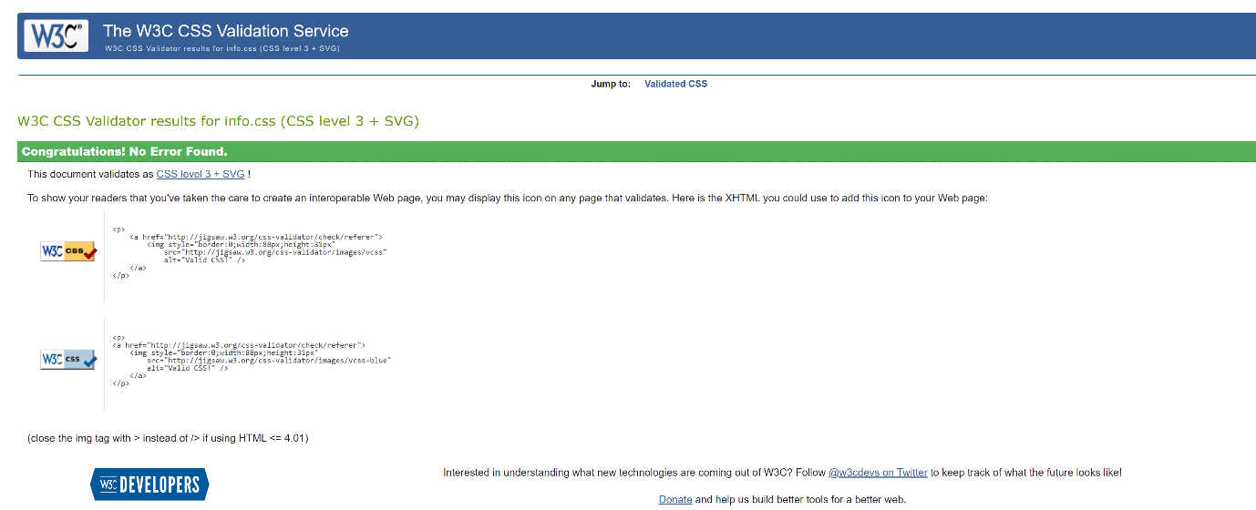

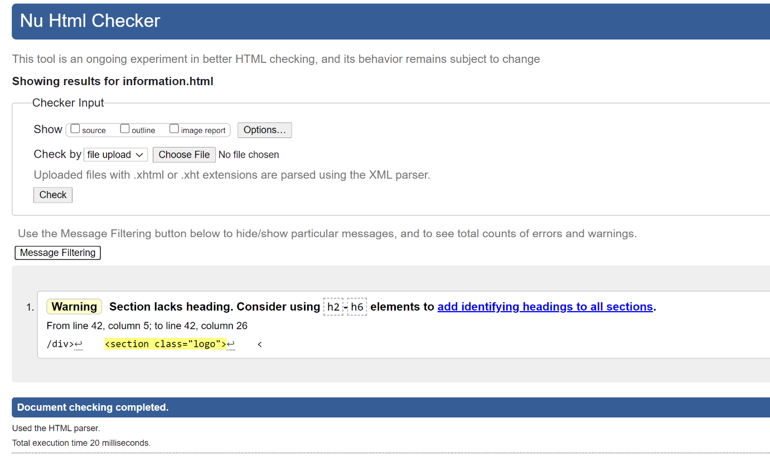

Gallery footer



Validation

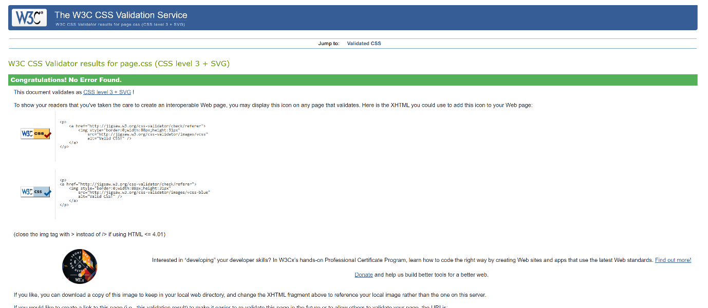

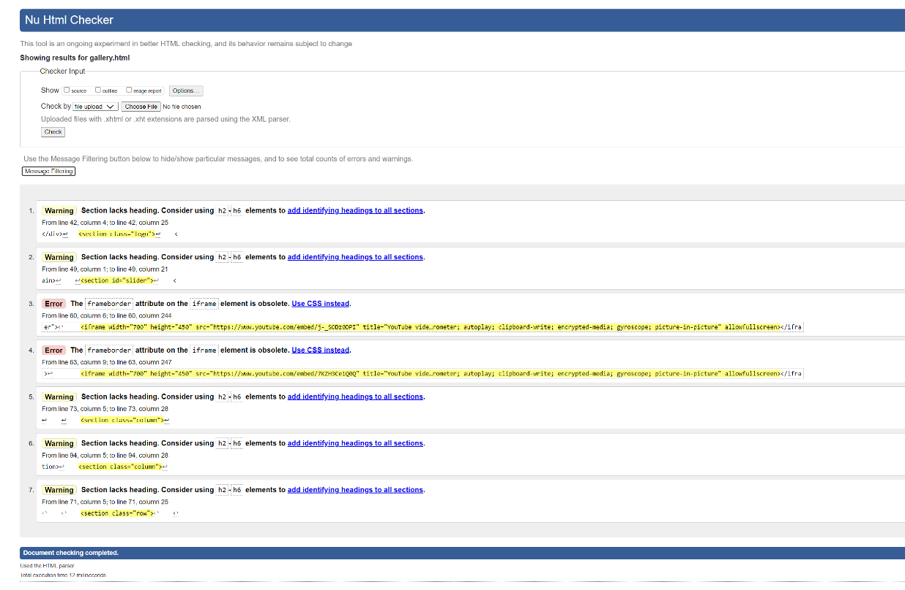

All pages have HTML/CSS validation, the CSS validation was all correct, to be able to use the CSS validator image. The HTML validation had some warnings, on one page where <iframe> tags where used the validation showed two errors, so was unable to use the HTML validation image.

Home page (index)

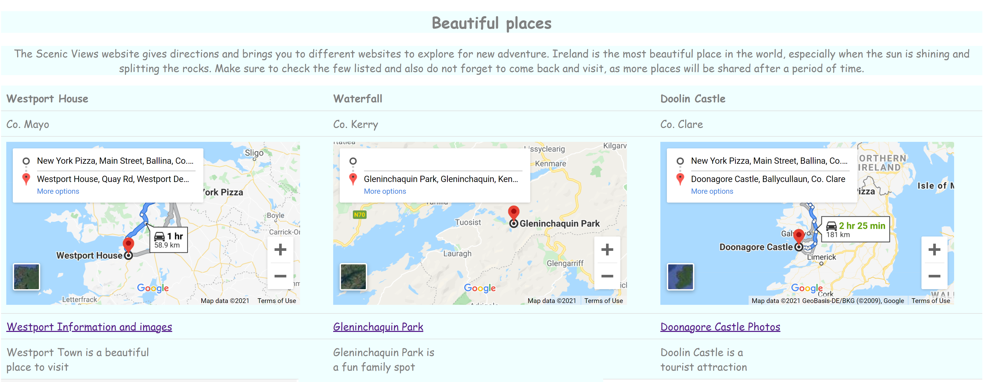

In the above image is a table format. This includes text, google maps and inks inside the <table> tag.

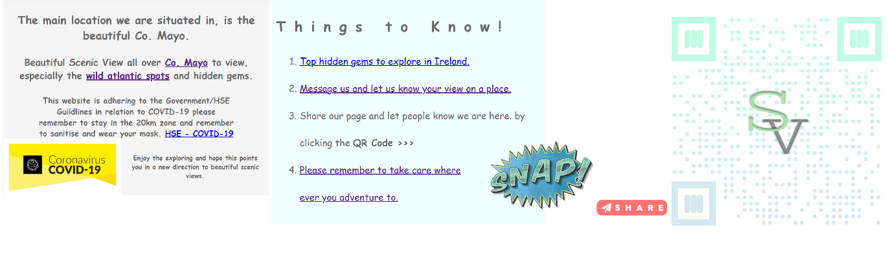

* The above image shown, includes <aside>, <article> and a second <aside> tag. The <aside> has context, links and COVID 19 image to advise people to continue to follow the guidelines, that the Government/HSE has put in place to keep everyone safe.
* The <article> tag contains an ordered list tag, with links to external websites and the third one, just lets you know you can snap and share the QR code to your friends and family.
* The images in the second <aside> tag contain QR code, snap image and share image.



The QR code was created on <https://www.qrcode-monkey.com/>



This image (png) is from <https://pngtree.com/> , which the site membership package is a paid for lifetime package. Which contain PSD, PNG, EPS images etc…



This share image (png) is also downloaded from pngtree.

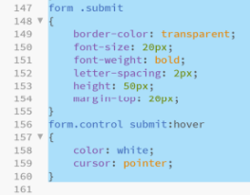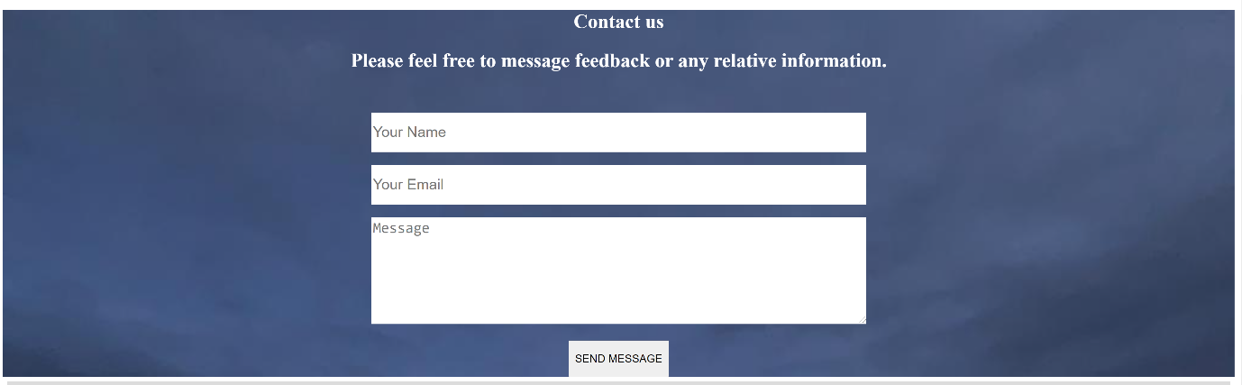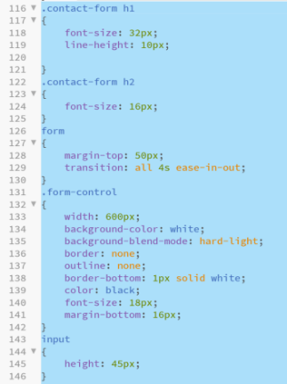About page

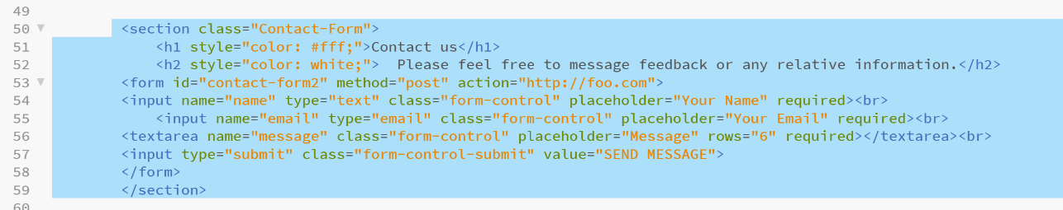

The about page contains a contact form using <form> tag inside a <section>.

The CSS is to include the visual look on the front end of the webpage.

Information page

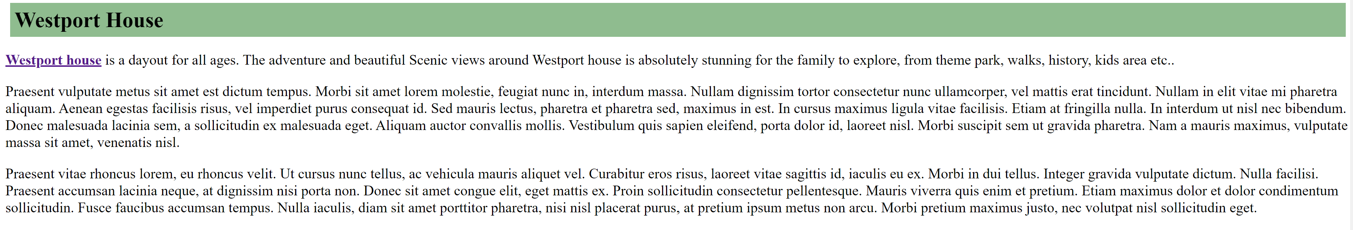

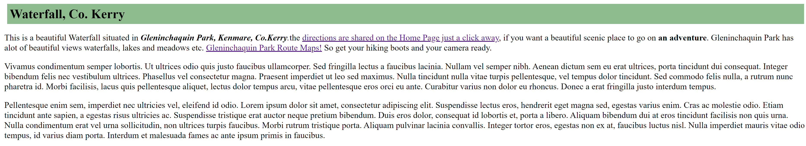

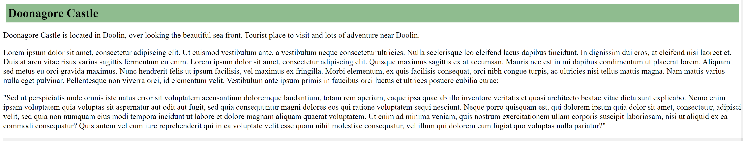

The information page contains a section, within this <section> tag contains <h1> tags and <p> tags to create context appropriate for Scenic Views website.

Gallery Page

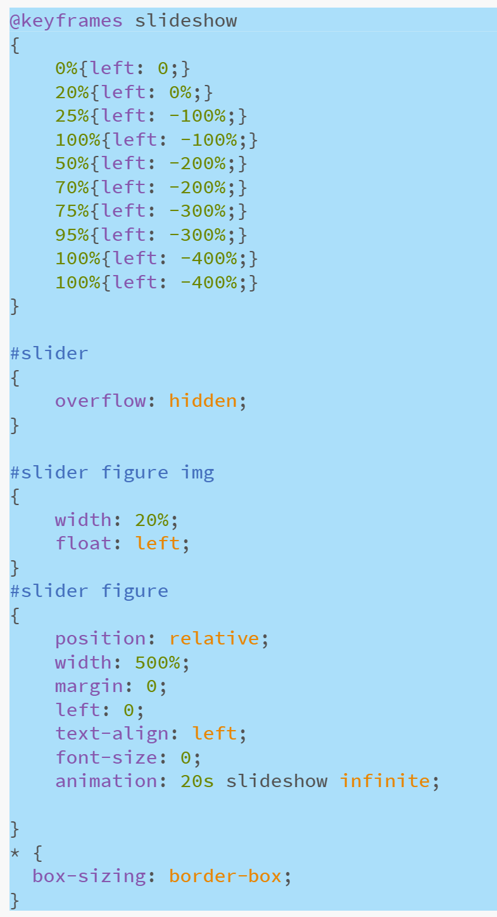The gallery contains a slider which has @keyframes to slide the images left in CSS, the HTML tags used to create this is a <section> which has inside a <figure> tag is used.

CSS includes animation to create a 20s infinite slideshow, this runs continuously on the page.

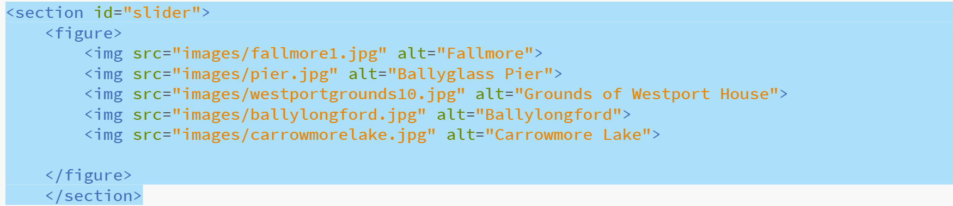

Web design Proposed.

The website was created in promoting Scenic Views, to boost exercise and help mental health without stating these facts.

The audience this site is available to is all-age group’s young to old, can be couples, family, friends or even an adventure with college/work buddies.

This website has images taken because it is nice to share beautiful images which inspires individuals, who are photographers or anybody who loves to snap a nice photo whatever the angle is.

In the contact form you can contact the page with suggestions of a stunning view you would like posted on the webpage.

The [presentation of proposal](https://github.com/TaniaWinters/ScenicViews) before the website was coded.

Project Checklist.

Conclusion

The Scenic Views website shows consistency throughout the webpages. The pages contain different html tags to create different context throughout the website. The website was created in ordered to share stunning views with other individuals and inspire in many ways without sharing it on the site.



